UNIVERSITY OF WITWATERSRAND

STUDENT NAMES: Michaela Bussey | Rayyan Gafoor | Julliette Love

STUDENT NO.: 2090536 | 1839637

CLASS NAME: Game Design IIIB-2021-SM2

COURSE CODE: WSOA3003A

TASK: Game Design Document

DUE DATE: 16 June 2022

WORD COUNT:

PLAGIARISM DECLARATION

1. I know that plagiarism is wrong. Plagiarism is to use another’s work to pretend that it is one’s own.
2. I have used author date convention for citation and referencing. Each significant contribution to and quotation in this essay from the work or works of other people has been acknowledged through citation and reference.
3. This essay is my own.
4. I have not allowed and will not allow anyone to copy my work with the intention of passing it off as his or her own.
5. I have done the word processing and formatting of this assignment myself, I understand that the correct formatting is part of the mark for this assignment and that it is therefore wrong for another person to do it for me.

Signature: Date: 16/06/2022

*Unsigned submissions will not be marked.*

Game Design Document - A Valve in Time

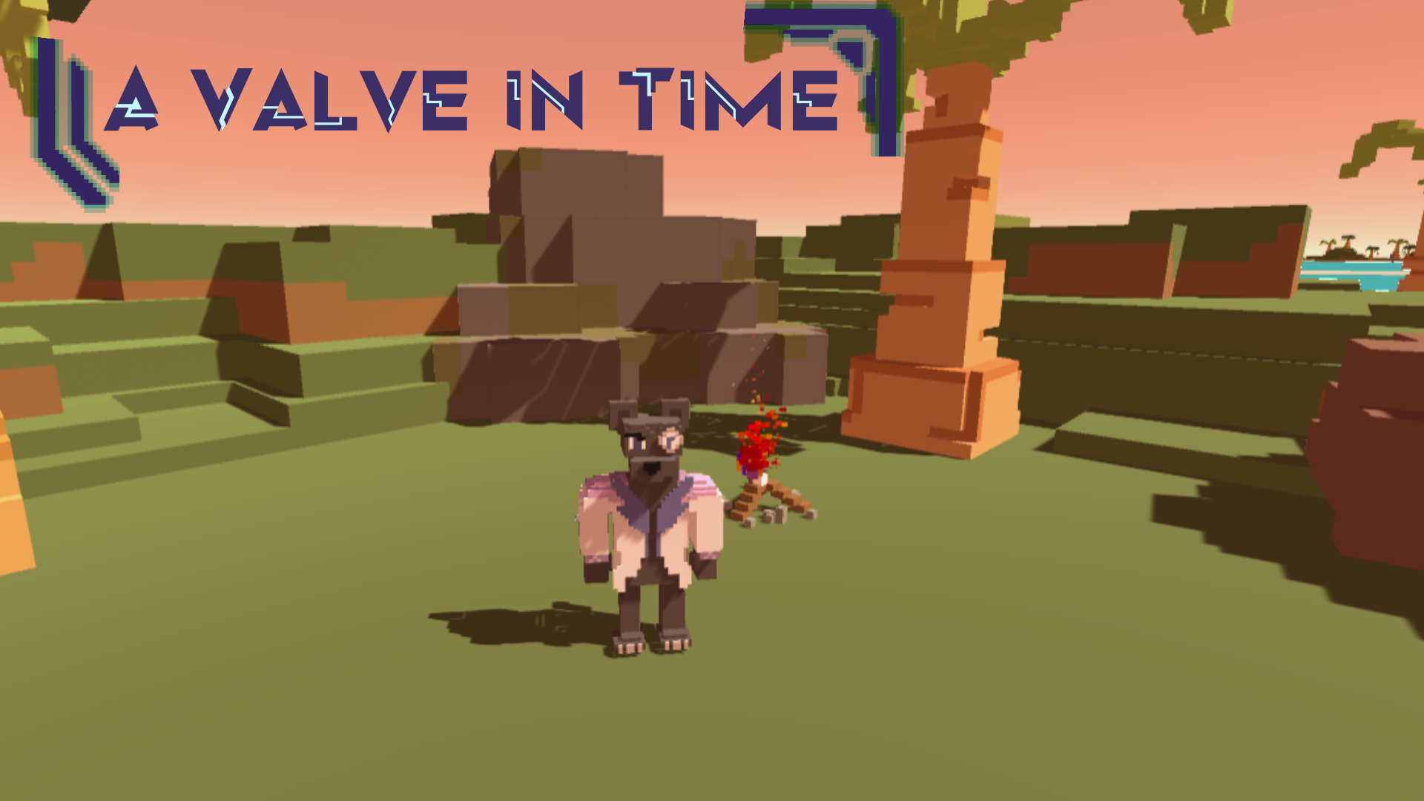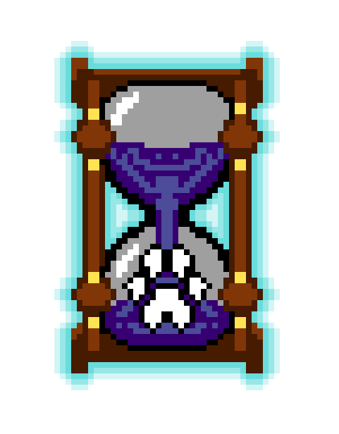

**Project Introduction/Executive summary**

A Valve in Time is constructed around the mechanic of time travelling. In order to progress through the game, the player will solve puzzles in the present by travelling back to the “past” and performing specific actions, which will affect the “present” scene in various ways. The goal of the team is to illustrate the mechanical design process by creating a game which revolves around the mechanic of time travel. Through this mechanic, the player is able to manipulate the environment and cause visible changes to the different time states. The game is set on a dinosaur-ridden tropical island, where the player must survive by time travelling and solving puzzle levels until they are confronted by a final boss area. Each of the puzzles presented to the player will let them progress in a linear way through the game, with the ultimate goal of escaping the island. This will be a third-person game, where the player can see the main character, Valve, but in future iterations, the team would like to change to an isometric camera instead. The art style will be in a semi-detailed voxel style, with a vibrant, tropical colour palette. Since our game has futuristic themes, character and enemy designs will not be historically accurate, as the game takes place separate from ordinary reality. As a result of this, creative liberty will be taken when designing the enemies and characters. The time travel mechanic was inspired by the game *Dishonored 2* (2016). The game’s 7th mission, “A Crack in the Slab”, uses time as both a theme and a mechanic. None of the members had ever worked with the concept of time as a mechanic, and thus it was decided that this would pose a valuable challenge. The music in this game will be simple and will function to reinforce the time travel mechanic by changing when the player time travels. The sound effects will draw attention to important narrative beats of the game, such as the fireplace and letters. Furthermore, they will also draw attention to the enemies so that their locations are reinforced to the player as well as to make the experience more immersive. The user interface will be minimalistic and communicate information regarding the main mechanics to the player. The letters will have a futuristic theme and communicate parts of the narrative to the player, as well as being a part of the turorialisation process. There will be two types of enemies, a static enemy and a patrolling enemy. These enemies should challenge the player to make use of the various mechanics provided to them in order to progress past the enemies. The Enemy AI, for the purpose of the prototype, should cover the basic mechanics of patrolling, searching and detection.

**Project Outcome and Requirements**

This game should demonstrate the mechanic of time travel in a way which is engaging and interesting to the players and feels cohesive with the rest of the gameplay and gameworld. The visuals should be semi-detailed voxel art, with a simplistic world and assets that are easy to produce within the given timeframe. The narrative is portrayed to the player in the form of letters left by a past time traveller, and will introduce the player to the world in a way which does not break immersion. Furthermore, letters left for the player will function as a tutorial by introducing the basic mechanics to the player. For this specific project, the team wishes to present two levels that effectively communicate the narrative plot of the time traveller who existed before Valve, and their journey they experienced. Furthermore, three dinosaur assets will be produced, along with two trees, and two rock objects. In terms of the enemy AI, we wanted to make use of a simple player detection mechanic. The enemy has two scouting states. In one state they will stay in one position and look around them and in the other they will follow specific routes, which the player can then learn. The enemy detection system relies on three detection variables; is the player in range, is the player in the line of sight, and is the player within detection range. If all these state requirements are met the enemy should focus on the player until their detection meter fills, which then prompts the player to respawn.

**Game Inspirations**

The primary inspiration for this game was the concept of time travel and how this can be translated into a game mechanic, as with *Dishonored 2*. How you deal with specific situations in the past determines the entire timeline regarding the main Non-Playable-Character (NPC) target in the level as well as the level itself. The level design focuses on encouraging the player to learn more about this unique level’s world. Furthermore, the player will learn more about the NPC through the actions the player makes between the two timelines. These actions ultimately result in minor and/or major changes to both the level and the NPC. The time mechanic is used in two main ways; First it is used as an exploration mechanic, as the player needs to jump between timelines to progress further in the level. The second is stealth, used to evade enemies which is heavily associated with the game series. What helps with the stealth mechanic of the game is essentially the time mechanics’ observation of the next timeline. This allows players to see into the next timeline before they time-jump, which assists the observation agency generally required by the player in stealth games.

The narrative game concept was created from this time travel mechanic, and was inspired by series like ‘Doctor Who’. Thereafter, we looked at several games as inspiration for the graphic and aesthetic representation. Firstly, *A Short Hike* (2020) was examined for its use of a simplistic art style and cute character designs. Furthermore, an important part of *A Short Hike* is its use of environmental puzzles which the player must solve to progress. Although the smaller scale of our gameworld means this will not take place on the same scale, this was still a valuable source of inspiration. Secondly, *Crossy Road* (2014) was examined for its use of minimalistic voxel art, but was ultimately scrapped as the artist felt they could not communicate the character designs effectively in this minimalist style. The simplistic hopping animation of the characters in *Crossy Road* was also an inspiration for the team’s possible animations. Furthermore, voxel was an art style that the artist wanted to experiment with in particular.

**Task Breakdown**

Rayyan - Red Michaela - Pink Juliette - Blue

| PRIMARY | SECONDARY | TERTIARY |
| --- | --- | --- |
| Picking up and dropping | Hopping animation | Free roaming enemy AI |
| Breaking objects | Time Travelling enemy | Rock formation 2 asset |
| Time Travelling | Customised skybox | Walking animations |
| Movement | Isometric camera | Dino charge animation |
| Rough overhead level sketch | Particle effects | Boss level landscape asset |
| Narrative | Shadow walking mechanic | Dino 3 asset |
| Main Character asset | Skeleton asset | Rock formation 3 assets |
| Dino 1 asset | Dino 2 asset | Tree 3 asset |
| Tree 1 asset | Tree 2 asset | Level 3 Landscape asset |
| Boulder asset | Letter display | Sound effects |
| Portal asset | Enemy patrol + detection AI | Enemy Focus AI |
| Fireplace asset | Shadow walking UI indicator | Enemy Guarding AI |
| Level 1 Landscape asset | Level 2 Landscape asset | Particle Effects |
| Past and present soundtrack |  |  |
| Enemy rotation detection AI |  |  |
| Puzzle code |  |  |
| Time travelling UI indicator |  |  |

The team used this table to keep track of every feature and task that was needed to be achieved. The tasks are split into their level of importance, with primary being the most necessary on the list, and tertiary being the least. The table is colour coded according to what each team member needs to work on so that everyone is able to clearly understand what they need to do. This also enables members to work on what they are strongest at, lightening the load off of others in the long run.

**3) Feature Lists**

Objectives

The aim of the player is to traverse the levels by solving puzzles in order to escape. To do this, the ability to travel back in time will be utilised as well as moving around the space and picking up and dropping specific items. Furthermore, enemies can be tactically avoided by using the shadow walking mechanic, discussed in detail below.

Gameplay Mechanics

The mechanics of ‘A Valve in Time’ consist of a simple movement and jump mechanic as the player moves around the scene, with the ability to rotate the camera around Valve. Furthermore, they are able to pick up, carry and drop specific items which are part of the puzzle solving in each level. The most important mechanic of the game is the time travelling mechanic, which enables the player to travel from the present to the past and vice versa. This, as mentioned before, helps in solving problems in the present scene by manipulating events and objects in the past. Lastly, the ability of shadow walking can be used to evade enemies for a period of time.

Level and Puzzle Design

The levels will be individually designed around each puzzle, as the terrain, objects and enemies all serve a purpose in the puzzle’s solution. As the puzzles were so integral to the team’s level design, these two aspects will be addressed together. Each island will represent a level, with a single themed puzzle per level. However, each puzzle may have multiple stages.

Level 1 Puzzle overhead sketch:

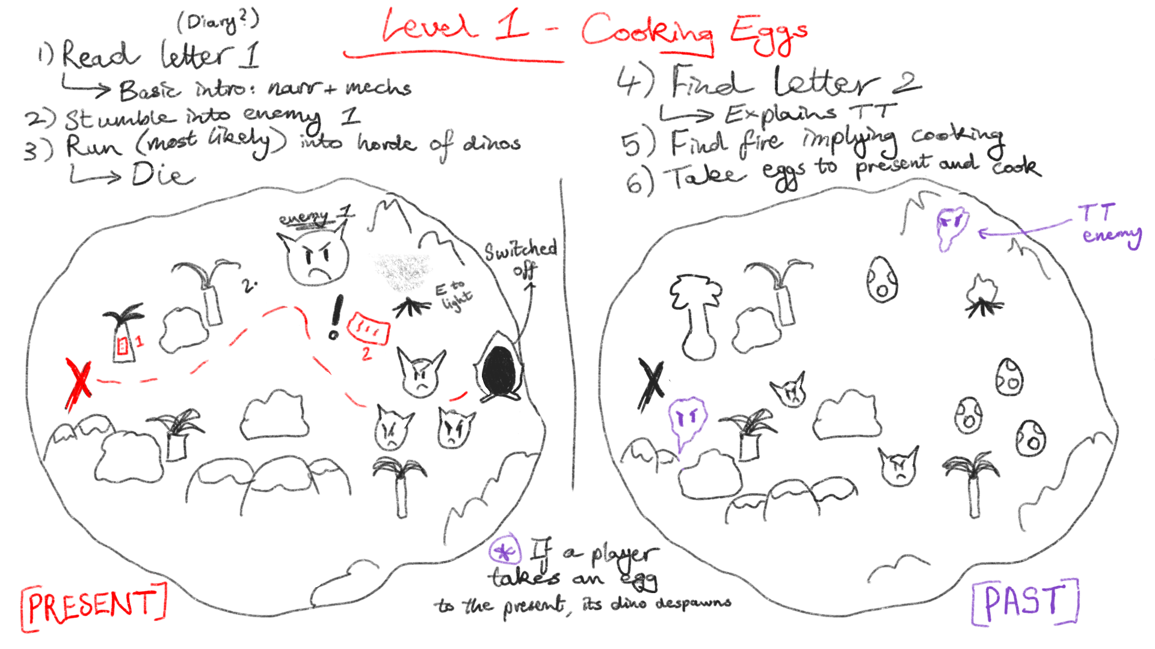

The goal when designing this level is to teach the player how to use the basic movement mechanic as well as the time travel mechanic. Firstly, the player will spawn in the scene at the red ‘X’ as shown on the plan above. Thereafter, they will encounter the first letter right in front of them, which will introduce the basic narrative told by a time traveller called Zye. After some exploration, they will come across a fireplace and the portal. Objects in the level as well as raised terrain form a path for the player and makes sure that they see the portal on the other side of the map. Enemy dinosaurs act as obstacles and directional influences for the player movement in this puzzle, and if the player were to walk straight to the portal they would die. The campfire functions as a narrative beat in the story, as it has been left there by Zye. Furthermore, a letter will be found there which explains the mechanic of time travel. The intention of this is to lead the player to travelling back in time, where they will find dinosaur eggs. By picking up these eggs and bringing them back to the present, the dinosaurs in the present were planned to despawn, as the eggs that they originally hatched from have been removed - This was the team’s original plan but we did not get implemented in time. By moving these eggs to the fireplace as a means of cooking them, the player will then be free to access the portal to move to the second level. The overall goal for this level is to teach mechanics, as well as utilise the puzzle concept of defeating enemies in other ways than combat.

Final level design:

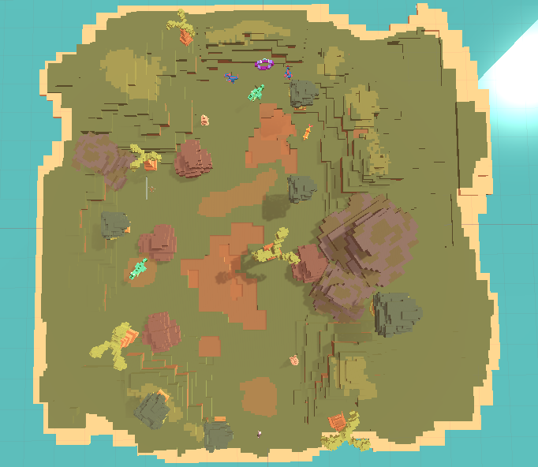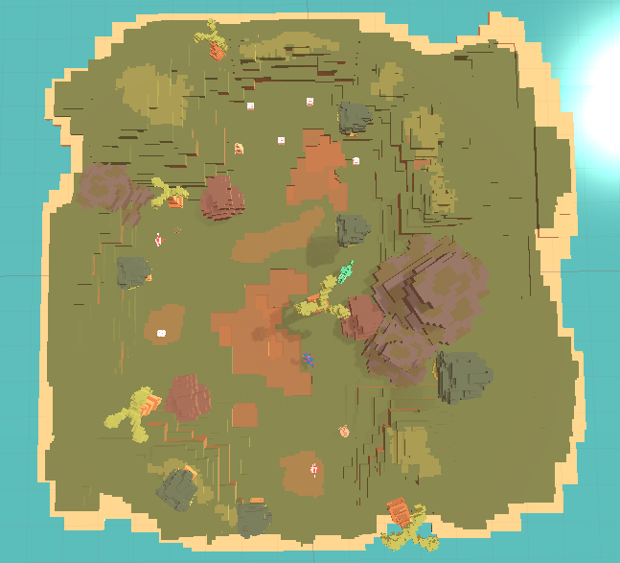

Level 2 Puzzle overhead sketch:

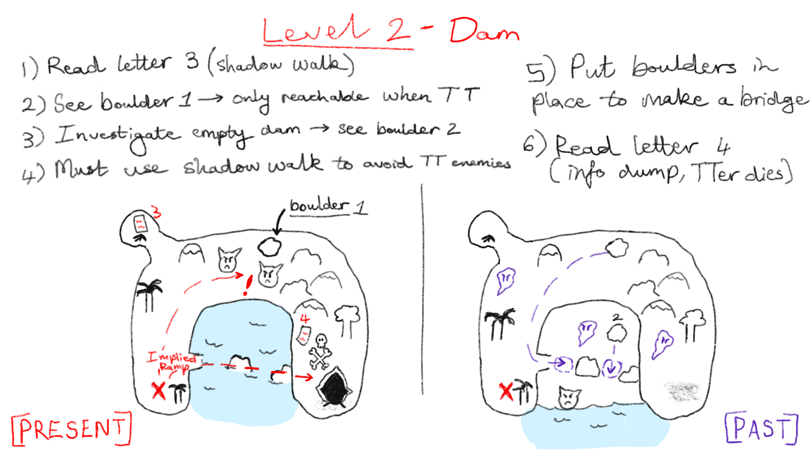

The goal of this level is to teach the player how to use the shadow walking mechanic. This is a mechanic which transforms the player into smoke, allowing them to move past enemies without being detected for a short period of time. In this level, the player spawns at one end of a horseshoe-shaped island. They will be able to see the portal, however, they will be blocked from reaching it by both a fissure in the terrain as well as enemy dinosaurs. The only way to get to the portal is by repairing a stone bridge which crosses the water, by using boulders. The first boulder in the present is blocked by dinosaurs. In order to retrieve it, the player must travel to the past where there are no dinosaurs in this area of the map, but only a lone time travelling enemy. The player can use this boulder in the past to create the bridge, as in the past the dam does not exist yet. The second boulder will be found in the empty dam in the past. Both of these must be retrieved with the aid of shadow walking. Thereafter the bridge can be repaired. Once crossing the bridge, the player will be able to find the fourth and final letter, which is left by a skeleton. This letter says goodbye to the player, as Zye has died. This represents the end of the tutorialisation process.

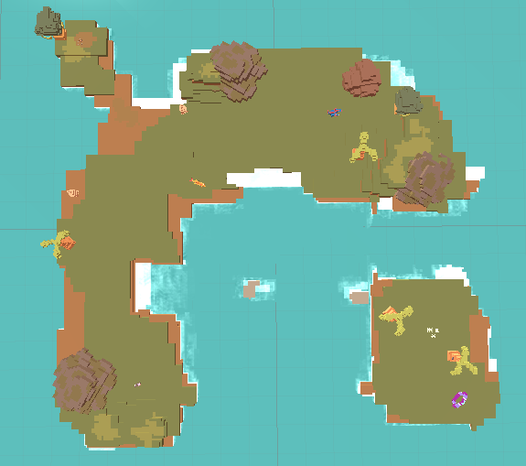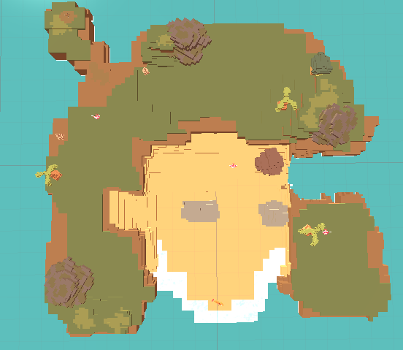

Level 3 puzzle design:

The goal of the third puzzle is to test the player on both of the primary mechanics taught in levels 1 and 2: time travelling and shadow walking. Therefore, this will be an environmental puzzle challenge while evading and defeating enemies. In the level, the player will see an abandoned futuristic machine next to where they spawn. Although the portal will be near their spawn area, it will be broken with pieces scattered around the level. However, there will be many dinosaurs guarding these broken pieces. Travelling forward through the level, they will find a dinosaur which is covered with black and purple particle effects. If the player travels to the past, they will find many aggressive dinosaurs which they must avoid using shadow walking. In the past they will also find a dinosaur carcass and the player will be able to pick up some of this dinosaur meat. If they do this, and return back to the present, the corrupted dinosaur will follow them. If the player leads this dinosaur to a pool of lava, this dinosaur will fall in. In return, the player will receive a computer chip that was embedded within this dinosaur. Once the player returns to the machine and inserts this chip, all the dinosaurs in the area will move towards the machine. In this way, the player will be able to collect portal fragments, build the portal and continue to the next level.

Final boss puzzle design:

When the player enters into this level, they will come into contact with a large mechanical Tyrannosaurus Rex that is able to time travel between the past and present as it follows the player. This level will require the player to quickly and strategically use shadow walking and time travelling to evade this dinosaur’s attacks. This mechanical dinosaur will also chase the player once they have seen the player move. However, if the player is still, it will not notice them. In this way, the player must find the components of the damaged portal and collect them, whilst using the environment to their advantage and remaining hidden. There will also be parts of the level such as overhanging cliffs or caves which will stop the mechanical Tyrannosaurus Rex from reaching them.

Narrative

The player plays a character named Valve who is a time traveller. However, Valve becomes trapped in a time state that he is unable to time travel out from. His abilities are fairly limited, so he is forced to escape via a series of portals. Through the first two levels there are letters which another time traveller has written which help the player understand the narrative of the game as well as communicate the basic mechanics they need to use to escape from the levels. Through the first letter for example, it is explained that this character named Zye has also become stuck in time, even though his calculations were perfect. The letter has been included below for reference. Zye also mentions that he will reconstruct broken portals in order to try find his way back to the present. Although in its current iteration this character states that he will construct the portals himself, this will be changed as in later levels there are broken portals that the player must construct. It is impossible for Zye to have done this, as the player will find his bones in the second level as he died after being bitten by a dinosaur.

Another important element of the narrative in this game is the time travelling enemy called Time Watchers. These enemies are significant as they are not native to the current timeline in which the player is stuck in, but are rather placed there to prevent time travellers like the player from interfering with time. This gives a reason as to why they are in the world and why they are hostile to the player.

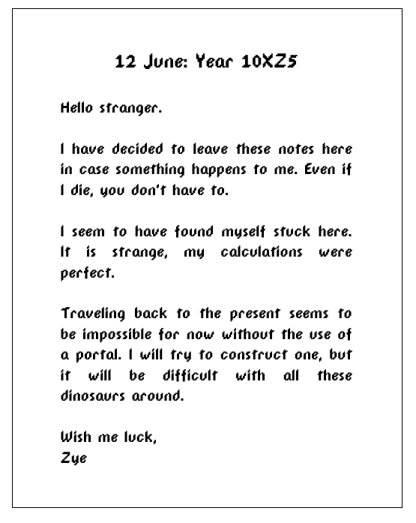

Aesthetics

Valve as a character was inspired by many different characters. Professors such as Professor Turo from Pokemon (1995-2022) seen below influenced the outfit design and colour palette of Valve. The build, animal design, and square silhouette of Valve was inspired by the fox character below, as the concept of an anthropomorphic main character felt unique and fitting for a futuristic game where anything is possible.

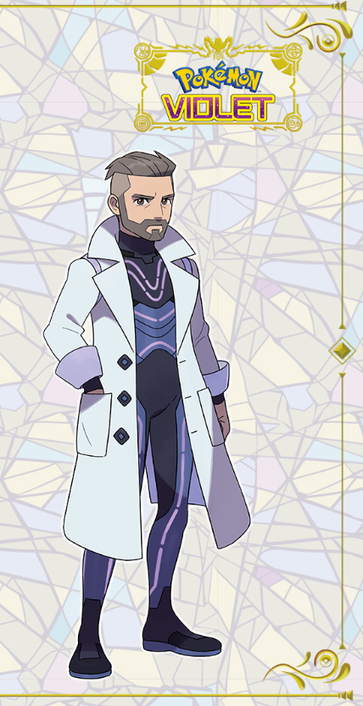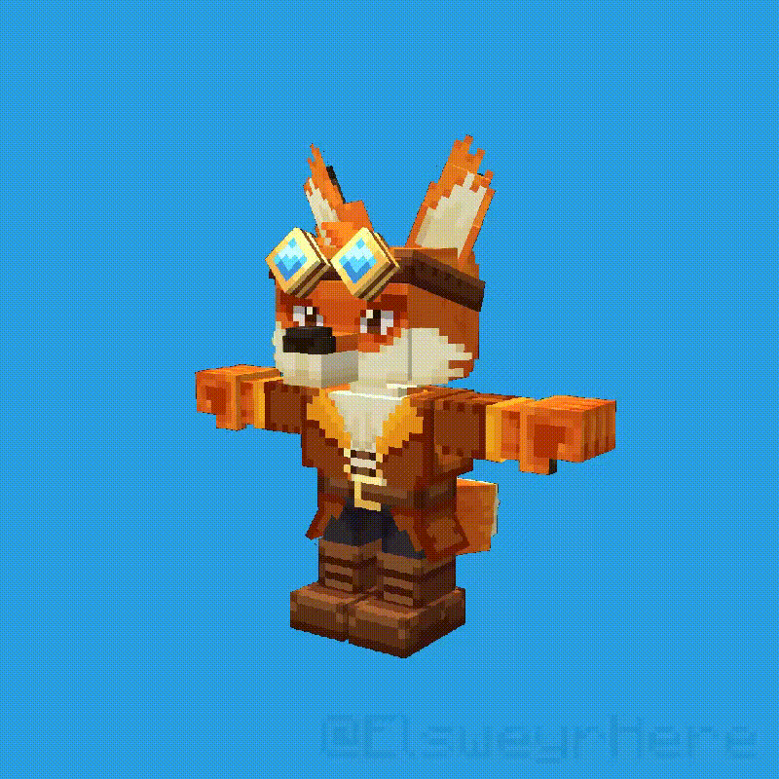

Symbols most commonly associated with time were utilised in Valve’s design, such as his left eye being a clock. Below is the concept art for him, and then the finished character sheet with his colour palette. These iterations of the character were kept and revisited as a means of keeping track of design progression, and served as a good practice to keep the design on track.

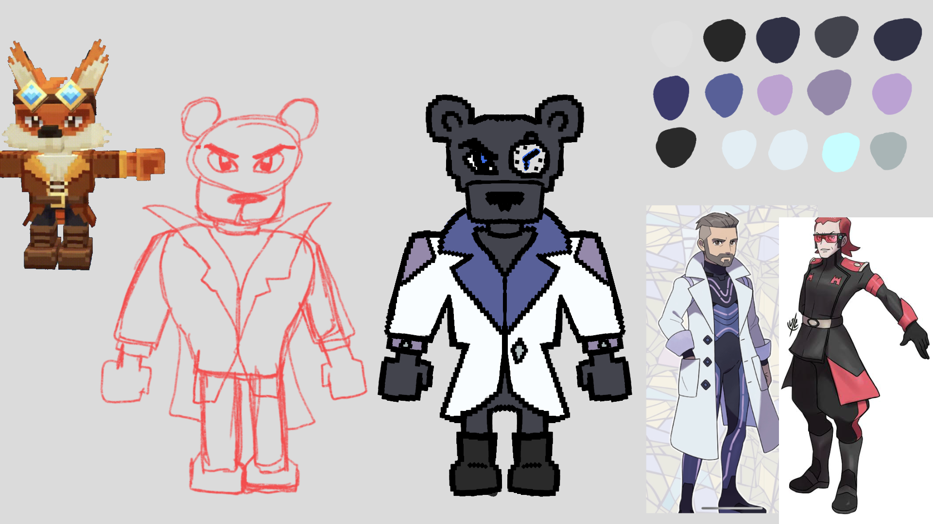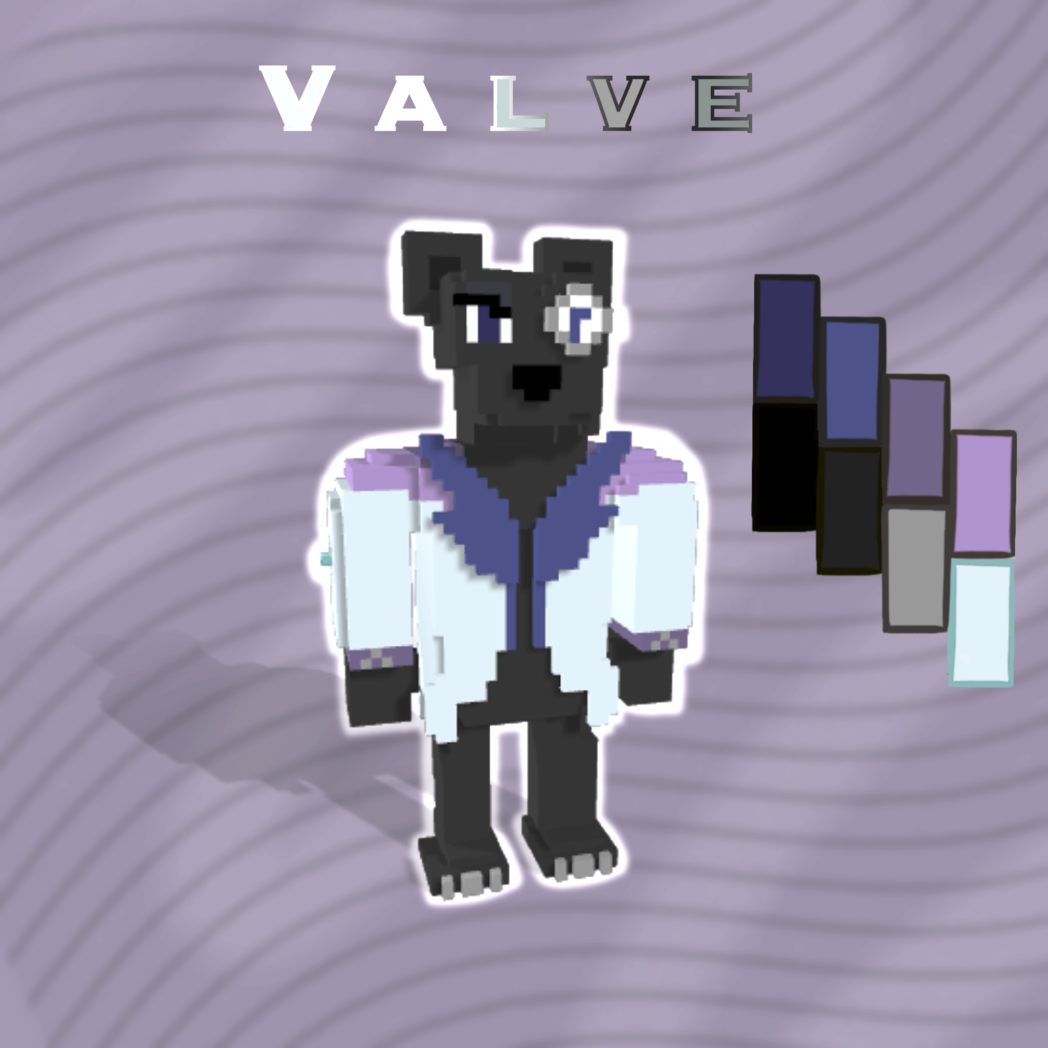

As mentioned before, *Crossy Road* was a great inspiration, and helped as a reference for voxel dinosaur designs. Below is a collection of *Crossy Road*’s dinosaurs that helped in the artist’s understanding of turning dinosaurs into voxel characters:

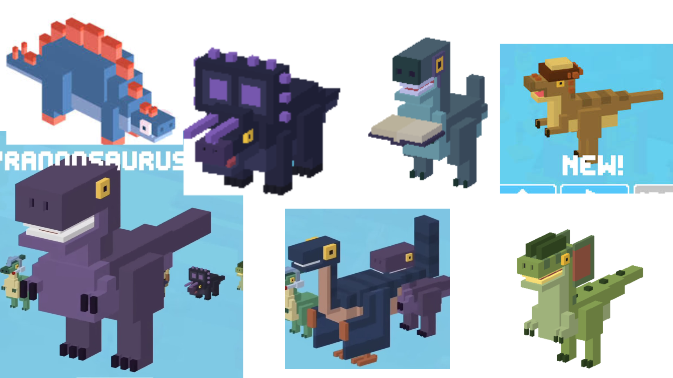

Creative liberty was used to make the game’s characters seem less realistic, as Valve himself was a time-travelling panther and a more fantastical cast of enemies would better suit him.

Finally, in terms of the environmental design, the dinosaur infested ‘Isle of Giants’ found in World of Warcraft (2004) was a great visual inspiration, with its vibrant and striking jungle flora. Below is a screenshot that shows how rich the colour palette of the island is, and alongside it is the colour palette used when constructing the voxel landscape.  
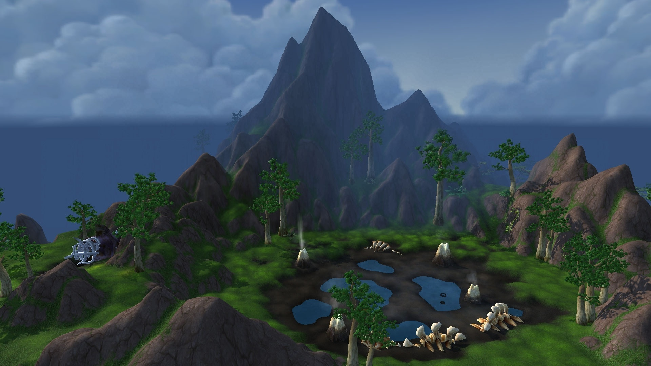

Interface and communication design

More specifically, there will be an hourglass symbol showing when the player can time travel and a bar at the top of the screen will show how long the player will be able to shadow walk for. Speak on futuristic space hub UI we found

PRIMARY FEATURES

Essential Mechanics

**Movement and Jump**: Movement in this game will require a simple WASD input in order to move forward, left, backwards and right. The ‘space’ key will be used to jump.

**Time Travelling**: The player will be able to click the right mouse button to travel back and forward in time. There will be a cooldown of seven seconds until the player can time travel again.

**Picking up/dropping**: The player will be able to pick up and drop certain objects in the game by clicking ‘E’ to pick up and ‘Q’ to drop. These objects will be used to solve puzzles and may be held as the player travels backwards and forwards in time.

**Enemy rotation detection AI**: Raycasts are used to detect if the player is close to the enemy. Once the player has been identified, the timer will increase which is indicated by the sphere displayed on the head of each enemy. Once this sphere has been filled, the player will die.

Communication Design

**Time state music**: Different music has been used for the ‘past’ map and the ‘present’ map. This functions to reinforce to the player that they are in a different time, otherwise they might become confused due to the similar layout of the level.

**Time travelling UI indicator**: An hourglass symbol in the bottom left corner of the screen functions to tell the player if they can time travel. The amount of the hourglass shown to the player shows how many seconds they must wait until they can time travel again. Once full, they will be either able to travel to the past or the present. There is a cool down of seven seconds which prevents the player from using this ability continuously.

**Narrative communication and tutorialisation**: Letters are situated throughout the first and second levels which communicate the basic narrative to the player, as well as briefly mentioning the mechanics that the player has access to, such as shadow walking. After the player has interacted with these letters, a UI panel will appear which tells them the controls they will need to perform these actions. When approaching an interactable object, the player will be presented with a paw icon and a symbol with the letter ‘E’, This shows that the letter ‘E’ must be pressed to pick up the object.

Assets

**Environmental assets**: The environmental assets refer to the actual terrain and scenery objects of the level, such as rocks and trees. The landscape asset will be made as one entire asset instead of building up the terrain in unity using separate elements. This will allow for the artist to use the selected programme, *MagicaVoxel* (2019), to completely construct the vision of the map sketch in one place. For the primary environmental assets, the artist must produce the Tree 1, Portal, and fireplace assets, as well as the Level 1 Landscape.

**Character assets**: The player’s character asset is a voxel art model of a panther named Valve. The enemy asset needed in the primary features is the first dinosaur.

**Interactable assets**: Interactable assets are the objects which can be picked up and dropped. These are the objects which are needed in order to solve puzzles. These include rocks and dinosaur eggs.

SECONDARY FEATURES

Secondary mechanics

**Shadow walking**: The player will be able to press ‘R’ on their keyboard to shadow walk. This will enable them to briefly transform into smoke, thereby remaining hidden from any enemies for a short period of time. In this way, detection of the player will only resume once the player has stopped shadow walking.

**Isometric camera**: The isometric camera was the team’s initial choice for the player perspective, but ultimately the group set up the player controls and camera through a third person perspective and found it too challenging to swap over to isometric - especially since no one was proficient at it or had done any projects in it. The isometric camera was planned to add a challenge of hiding visibility of what was coming ahead of the player, as in this perspective, elements of the game world can be hidden behind other objects. This could lead to an interesting mechanic of dinosaurs and enemies hiding behind places and ambushing the player. Below is a basic idea of what the map would look like in this perspective, and as seen it hides certain spots of the map.

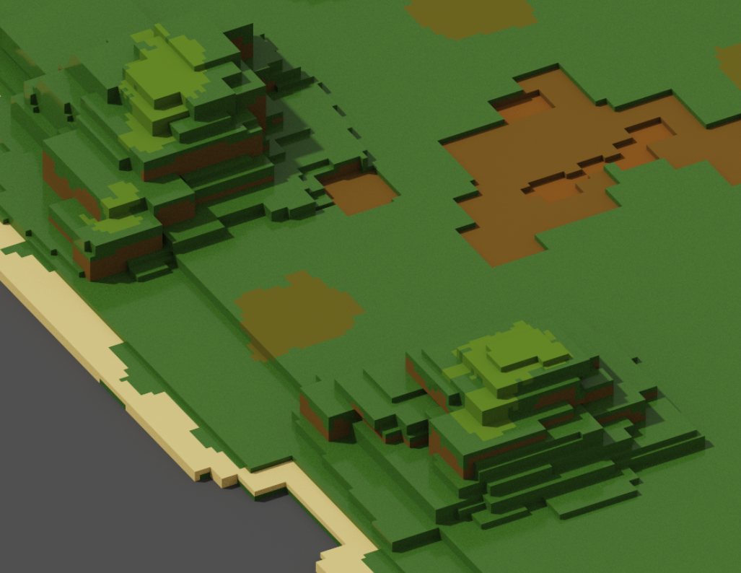

**Enemy patrol**: The enemies patrol through the level by following a set path. This will be a script that can be applied to any enemy to allow for modular pathing on different enemies.

Animations

**Hopping animation**: The enemies will hop in order to create the illusion of movement in a similar style to that of *Crossy Road*.

Assets

**Environmental assets:** Create a second asset of a different tree and the second level landscape. Make a skeleton asset for the second level, as well as adding particle effects to items such as the fireplace. This is also when the artist must create or find a skybox.

**Character assets:** Add a second dinosaur enemy, as well as the time travelling enemy.

Communication design

**Letter display**: The letters placed throughout the levels will communicate to the player parts of the narrative as well as what the controls are.

TERTIARY FEATURES

Additional Communication design

**Sound effects**: The sound effects will communicate the location of certain objects and enemies to the player. For example, the letters will make a particular sound as the player gets close to them. The dinosaurs will also make a sound when they detect the player, which communicates to the player that they are in danger.

Additional enemy AI

**Chase AI**: AI will be added where the enemies chase the player if they are a certain distance away from the enemy and if the player is moving. This will be utilised for the fourth level.

**Enemy Focus AI:** Rotate enemies gaze onto player when the player has been detected instead of freezing immediately.

**Enemy Gaurding AI**: When the enemy detects the presence of the player, they will move towards the suspected area they believe the player to be.

Assets

**Environmental assets:** This is where the artist can add extra tree, set dressing and interactable assets, as well as finishing up the landscape assets for the third level and the boss level terrain.

**Character assets:** Add the third dinosaur model, as well as the final boss.

**6) Dependencies**

| **Task** | **Dependencies** |
| --- | --- |
| Movement and jump | NA |
| Picking up and dropping items | Movement and jump |
| Time travelling | NA |
| Narrative and puzzle design | NA |
| Enemy rotation detection AI | Movement and jump |
| Level design | Narrative and puzzle design |
| Environmental assets | Narrative and puzzle design |
| Character assets | Narrative and puzzle design |
| Interactable assets | Narrative and puzzle design |
| Time state music | Time travelling |
| Time travelling UI indicator | Time travelling |
| Narrative communication and tutorialisation | Narrative and puzzle design, level design, Movement and jump |
| Shadow walking | Movement and jump, enemy rotation detection AI |
| Isometric camera | Movement and jump |
| Enemy patrol | Enemy rotation detection AI, movement and jump |
| Hopping animation | Character assets, enemy patrol |
| Letter display | Narrative and puzzle design, level design |
| Sound effects | Movement and jump, narrative and puzzle design |
| Chase AI | Movement and jump, narrative and puzzle design |
| Enemy focus AI | Movement and jump, narrative and puzzle design |
| Enemy guarding AI | Movement and jump, narrative and puzzle design |

**7) Risks**

High-level risks:

* Covid-19 or other sickness.
* Electrical Issues (Cable Theft | Load-Shedding)
* Hardware | Software Issues.

Low-level risks:

* Attending an event.
* Coinciding projects.

Risk Solutions;

* Planning using ClickUp as well as effective communication between group members.
* The use of GitHub in properly saving iterations and pushing any work done.
* Extra time allocated towards polishing can be used in the event of an emergency.

**8) Milestones**

Start Date: 20 May

Major Milestones:

| **Aspect** | **Dates** |
| --- | --- |
| Milestone 1   * Movement and camera * Picking up and dropping * Time Travelling * Rough overhead level sketch * Narrative * Main Character asset * Level 1 Landscape asset * Enemy rotation detection AI | 20 May - 1 June |
| Milestone 2   * Time Travelling enemy * Isometric camera * Particle effects * Shadow walking mechanic * Dino 1, Dino 2, Tree 1, Tree 2, Boulder, fireplace, skeleton, rock formation, and Portal asset * Enemy patrol + detection AI * Shadow walking UI indicator * Level 2 Landscape asset * Past and present soundtrack * Letter display * Puzzle code * Time travelling UI indicator | 1 - 16 June |
| Milestone 3   * Hopping, walking, and attack charge animations * Customised skybox * Level 3 and boss level landscape, final boss, dino 3, tree 3, and rock formation 2 asset * Free roaming enemy AI | 16 June - 30 June |
| Milestone 4   * Playtesting and Polishing * End Date: 30 June | 30 June - 7 July |

**9) Scheduling**

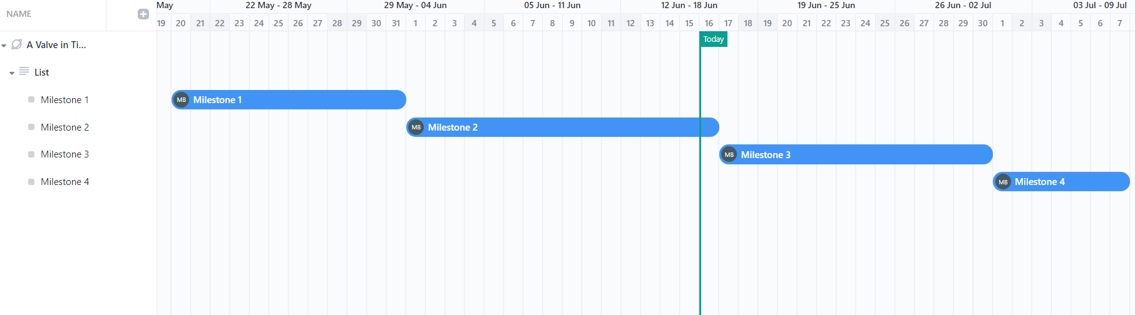

The scheduling follows the same layout as the milestones. Each team member will be working on multiple components within each milestone simultaneously according to the ‘Dependencies’, with some flexibility made available due to other projects as well as risks they may experience.

**10) References**

Ephtracy. *MagicaVoxel*. [program] (2019). Windows

Hipster Whale. *Crossy Road.* [Video game] (2014). Android, iOS, Windows Phone, tvOS

Bethesda. *Dishonored 2* [Video game] (2016). Playstation 4, Xbox One, Windows

Robinson-Yu, (2019). *A Short Hike* [Video game]. Microsoft Windows, macOS, Nintendo Switch, Linux